**Project Design Phase-II**

**Data Flow Diagram & User Stories**

|  |  |
| --- | --- |
| Date | 29 June 2025 |
| Team ID | LTVIP2025TMID35088 |
| Project Name | **Enhanced Wings: Marvels of Butterfly Species** |
| Maximum Marks | 4 Marks |

**Data Flow Diagrams:**

A Data Flow Diagram (DFD) is a traditional visual representation of the information flows within a system. A neat and clear DFD can depict the right amount of the system requirement graphically. It shows how data enters and leaves the system, what changes the information, and where data is stored.

**Example:** [**(Simplified)**](https://developer.ibm.com/patterns/visualize-unstructured-text/)

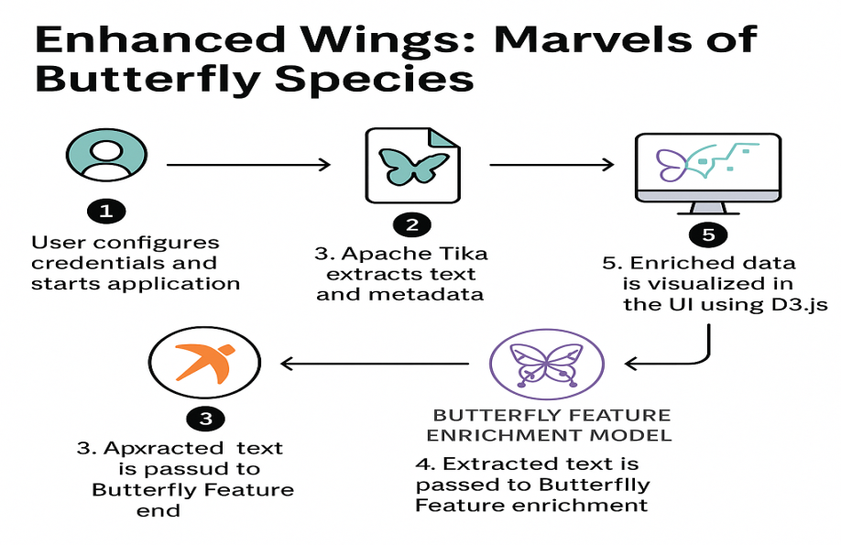

|  |  |  |  |  |  |
| --- | --- | --- | --- | --- | --- |
| **User Type** | **Functional Requirement (Epic)** | **User Story No.** | **User Story / Task** | **Acceptance Criteria** | **Priority** |
| Visitor | Registration | USN-1 | As a user, I can sign up with email/password. | Account is created. | High |
| Visitor | Registration | USN-2 | As a user, I can log in using Google. | Google login works. | Medium |
| User | Upload Image | USN-3 | As a user, I can upload a butterfly image. | Image is uploaded. | High |
| User | AI Prediction | USN-4 | As a user, I get species prediction results. | Result is displayed. | High |
| User | Species Information | USN-5 | As a user, I can view butterfly facts & conservation data. | Data shown on dashboard. | High |
| Admin | Model Training | USN-6 | As an admin, I can update the model with new data. | Model accepts update. | Medium |